RBEI/BS13

Index

1 Description 2

2 Audience 2

3 Pre-requisites 2

3.1 Installation 2

3.2 Best Practices 3

3.3 Accessing DMS Functions 3

3.3.1 ETAS specific functionality located on top 3

3.3.2 Tortoise functionality located under TortoiseSVN 4

3.4 SVN Check out 6

3.5 SVN Partial Check out 10

3.6 SVN Update 12

3.7 SVN Commit 13

3.8 SVN Add 16

3.9 SVN Repo-browser 22

3.10 Other SVN Features 24

3.11 Features and other uses of ETAS DMS 26

3.11.1 ETAS DMS Copy from Shared 27

3.11.2 ETAS DMS Release 29

3.11.3 ETAS DMS Status 30

3.11.4 ETAS DMS Url to Clipboard 31

3.11.5 SVN-Edit 31

3.12 Known Issues 33

4 References 34

# Description

This document provides the best practices and describes proper know-how of several components available as part of ETAS DMS System (Document Management System)

Current ETAS DMS URL: <https://etasdmstest2.de.bosch.com/svn/>

Audience

This document can be used by all the users using ETAS DMS System for maintaining and managing all their public, private, internal and confidential documents and other information.

# Pre-requisites

## Installation

* You need to have the latest ETAS DMS version 3.2 software installed on your machine to be able to use and perform ETAS DMS Client related activities.
* You can check by running the command “svn info” from the CMD Prompt.
  + Goto the folder where you have downloaded the repository from the server.
  + Open a CMD Prompt at this folder.
  + Run “svn info”
* If you do not have the latest software, then
  + If you are an ETAS User, you can ask your local IT Support for installation.
  + If you are a RBEI User, you can email to CI-Hotline for further support.

All you’re installable and software would be installed inside the folder

|  |
| --- |
| **C:\Program Files (x86)\ETAS DMS** |

For ETAS DMS Status, Installation would be available at -

|  |
| --- |
| **C:\Program Files (x86)\ETAS DMS Status** |

After this installation and configuration, your machine will have the following software installed

* Tortoise SVN v1.10
* SVN Command line client tool v1.10
* ETAS DMS Status, ETAS DMS Release
* ETAS DMS Url To Clipboard, SVN-Edit
* ETAS DMS Copy from Shared

## Best Practices

Some of the best practices to use the ETAS DMS Software and mostly used subversion commands.

You could get a complete overview of all ETAS DMS Repositories you have access to by simply clicking the URL <https://etasdmstest2.de.bosch.com/svn/> either via Firefox or Explorer.

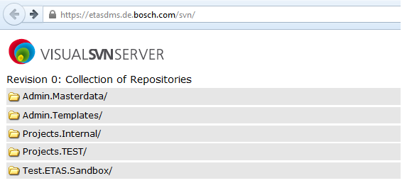

Once you identify the repository, you can click on the URL to copy the URL while performing an SVN Checkout on your local folder in the computer.

## Accessing DMS Functions

Everything starts with a right-click (left click for left-hand mouses)



### ETAS specific functionality located on top

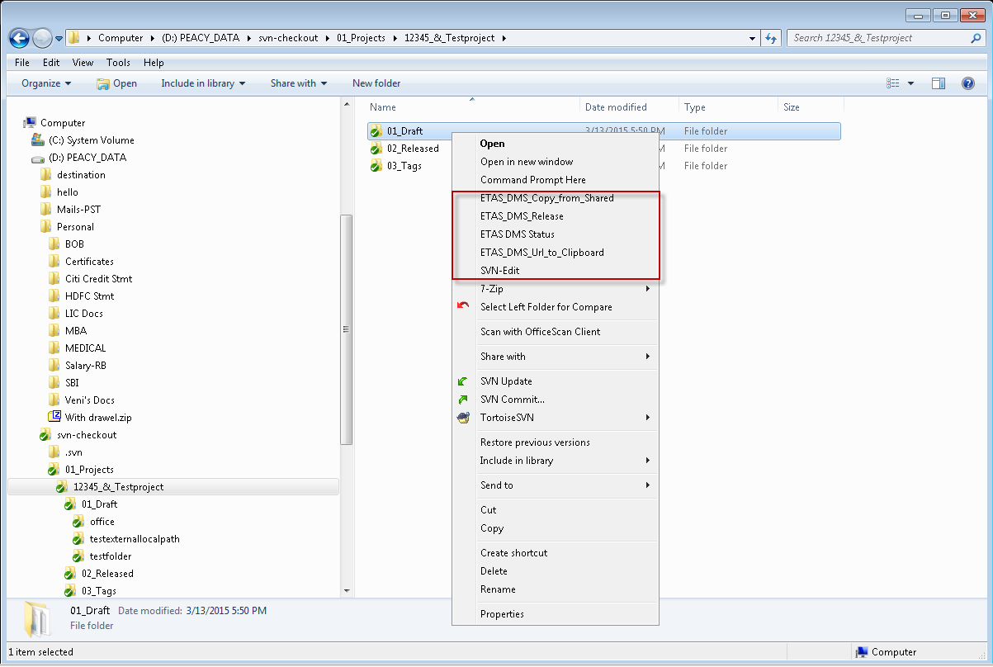

### Tortoise functionality located under TortoiseSVN

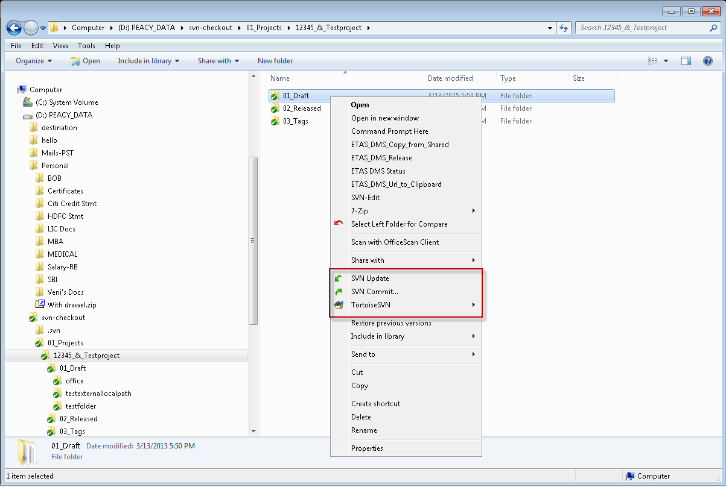

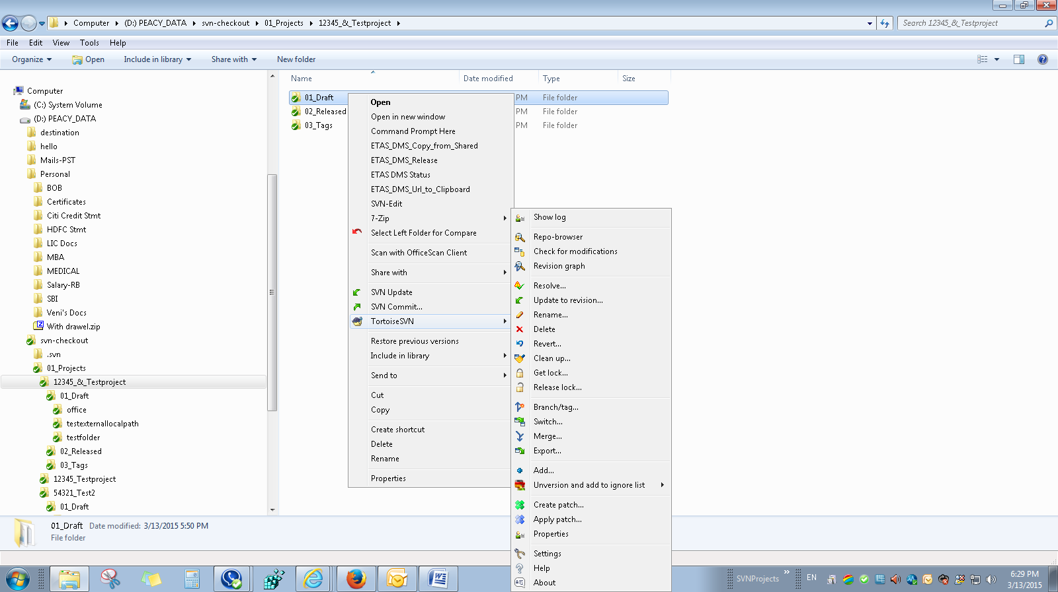

## SVN Check out

The only difference between SVN Checkout and SVN Export is that the export will not be version controlled and would simply be a plain download from the server.

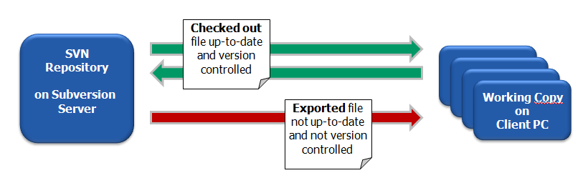

Any user having access to any repository at ETAS DMS will be able to download the contents by simply doing a checkout by using the URL.

***It is highly recommended that all the users excluding PM’s/PjM’s download or checkout 01_Drafts folder only from the server as most of them would only have access from 01_Dratfs folder and below.***

For performing an SVN Checkout, Please follow the instructions below.

1. Find the option ***SVN Checkout…*** from the context menu.

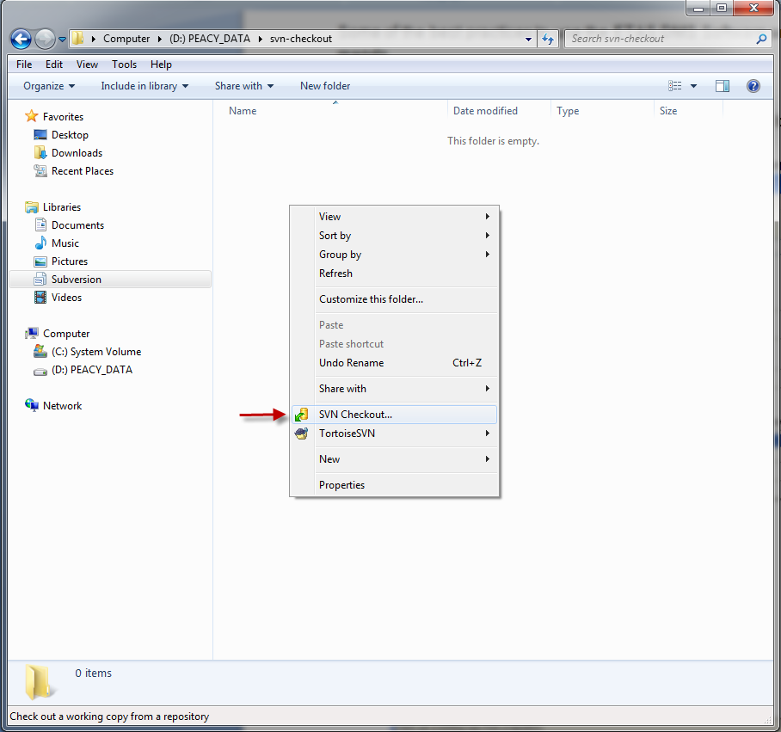

1. Put down the URL of repository and download the contents of the repository in the folder (Checkout Directory) you wanted to place your working copy. Unless you know what you are doing you should always checkout the HEAD revision of the repository.

If you enter a folder name that does not yet exist, then a directory with that name is created.

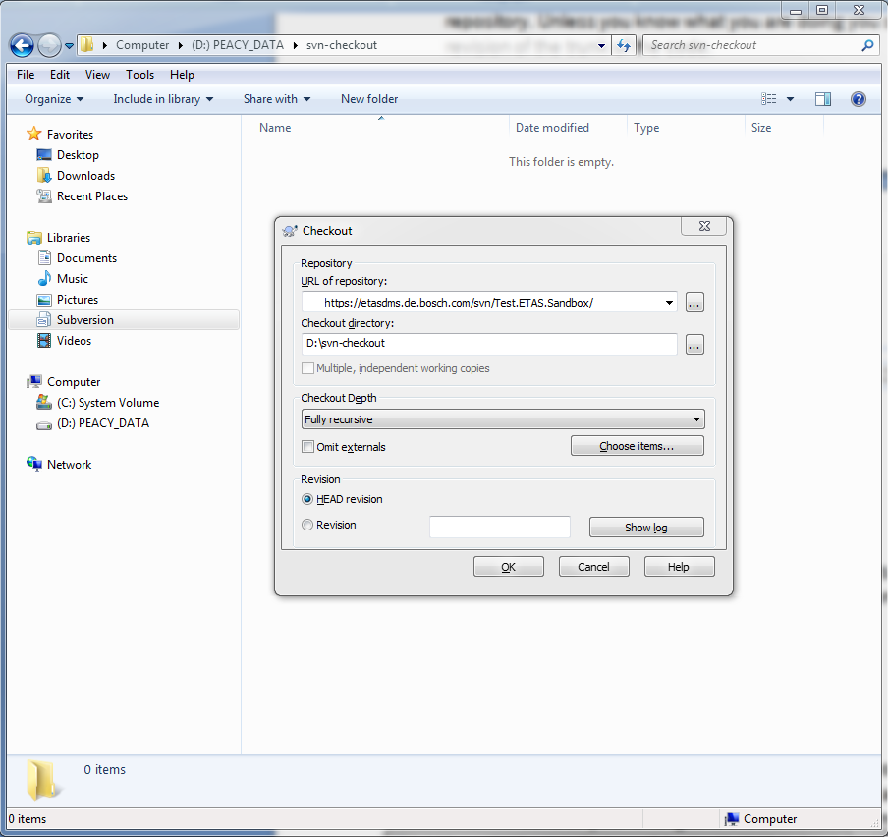

Click ***OK***.

If this was your first check out from the server, then it might ask you to accept certificates from the server, something like below.

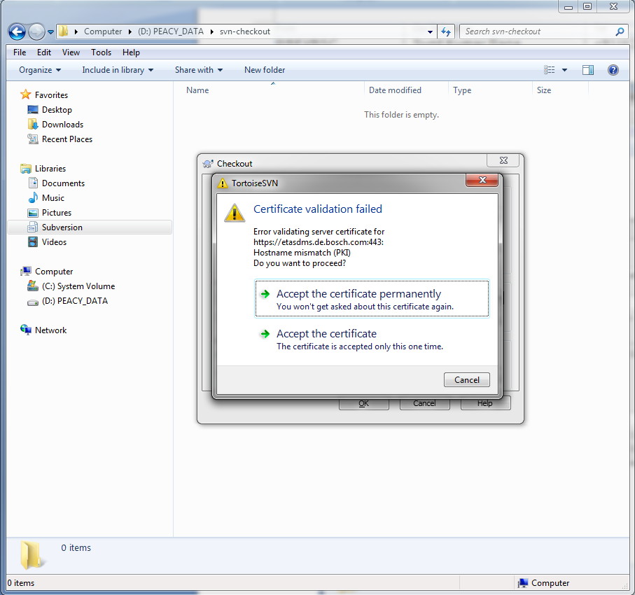

Click on the link “***Accept the certificate permanently***” so that the certificates are stored in the cache. After this, a window will open asking you to enter your credentials.

Use your credentials you login everyday on your working machine.

If you have used the same server i.e. etasdms.de.bosch.com already, then you might not see the above message.

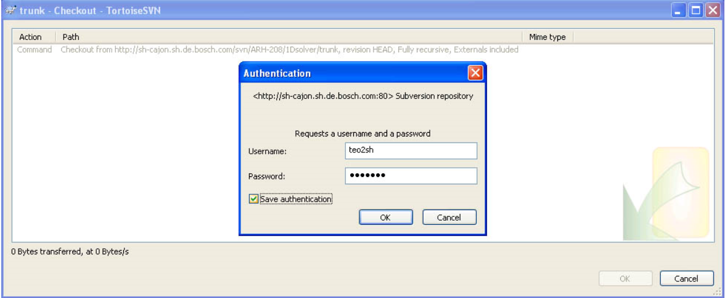

After you have checked out your working copy your folder should look similar to this:

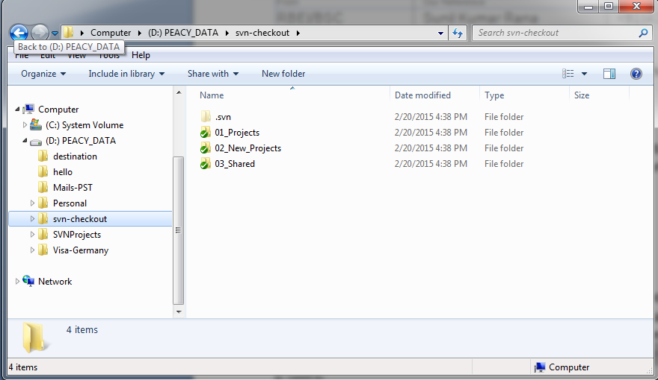

## SVN Partial Check out

Users have also the possibility to do a partial checkout. That means only check out the folders which are needed from the repository.

1. Use again the option “***SVN check out***” from the context menu
2. On the “Checkout” window click on “***Choose items…***”

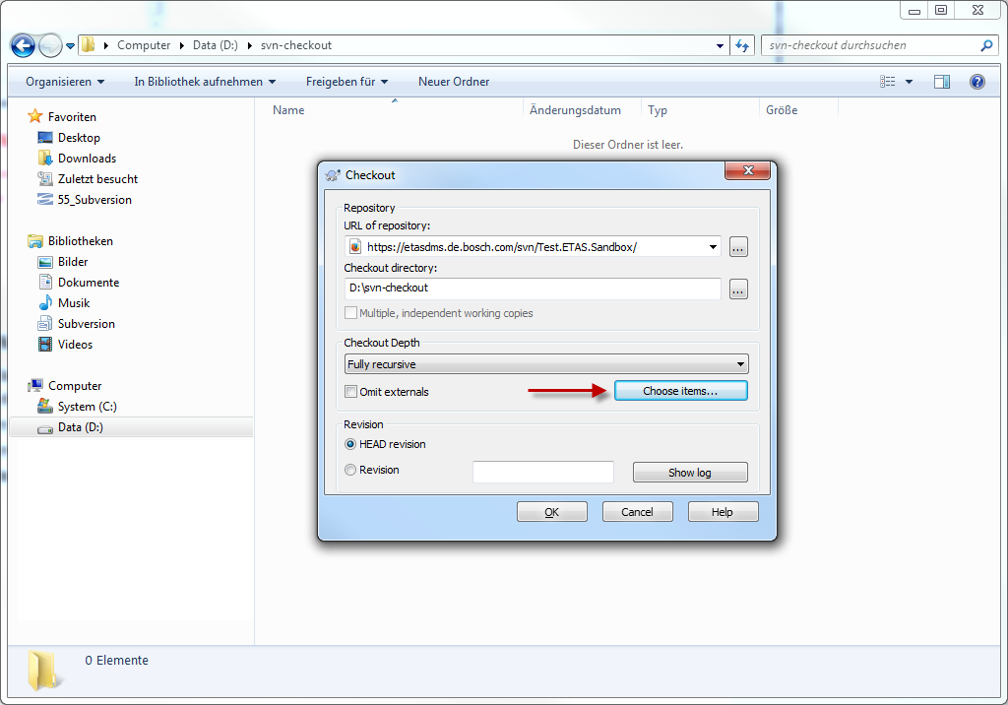

1. Choose the folders which you need to check out

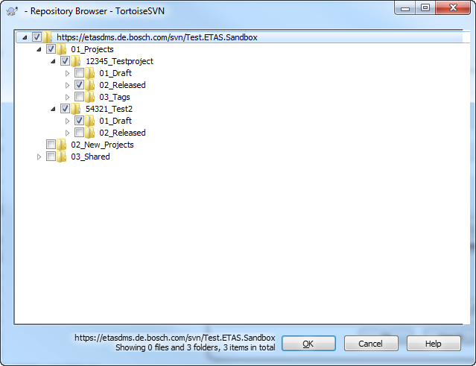

## SVN Update

SVN Update is very important and its use keeps the contents in your working copy up to date.

If you working copy is not updated, then it might results is conflicts and other issues while trying to perform any subversion related operations.

To perform SVN Update on your working copy, you need to just right click to find ***SVN Update*** in your context menu, shown in the screenshot like below.

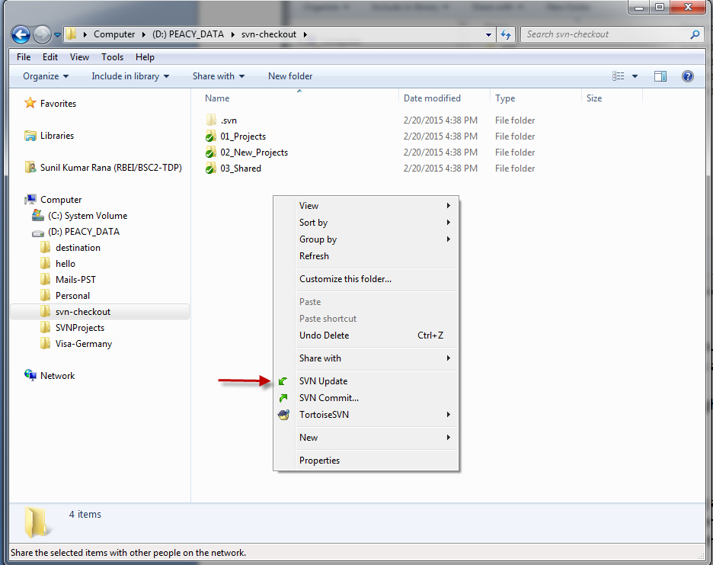

Once clicked, Tortoise SVN updates your working copy as shown below.

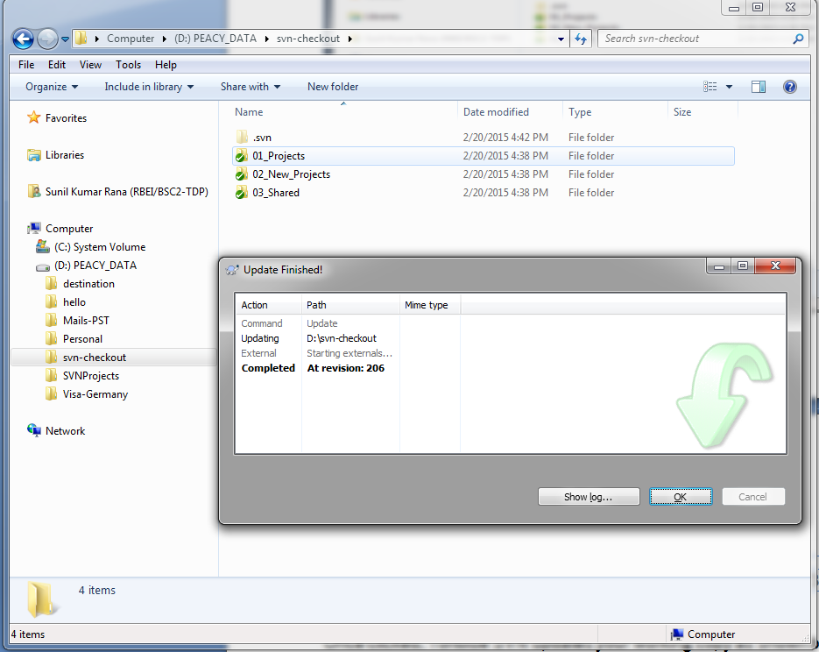

## SVN Commit

Please not that it is highly recommended that you first update your working copy before planning for doing any changes into your working copy.

Once your subversion copy is updated, then you can start working and modifying the contents of the repository. Once you are done with all changes, you can commit by clicking on ***SVN Commit*** that will send all your changes to the server and commits the changes into server.

After you have done the changes, the green tick will change into red exclamatory mark.

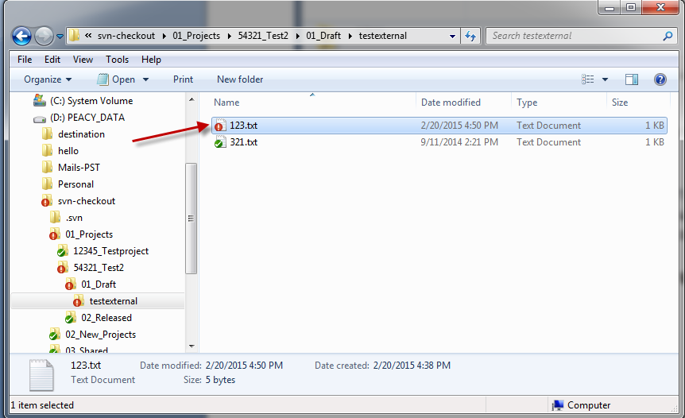

After you see the red tick mark, you can commit the file by clicking on ***SVN Commit***.

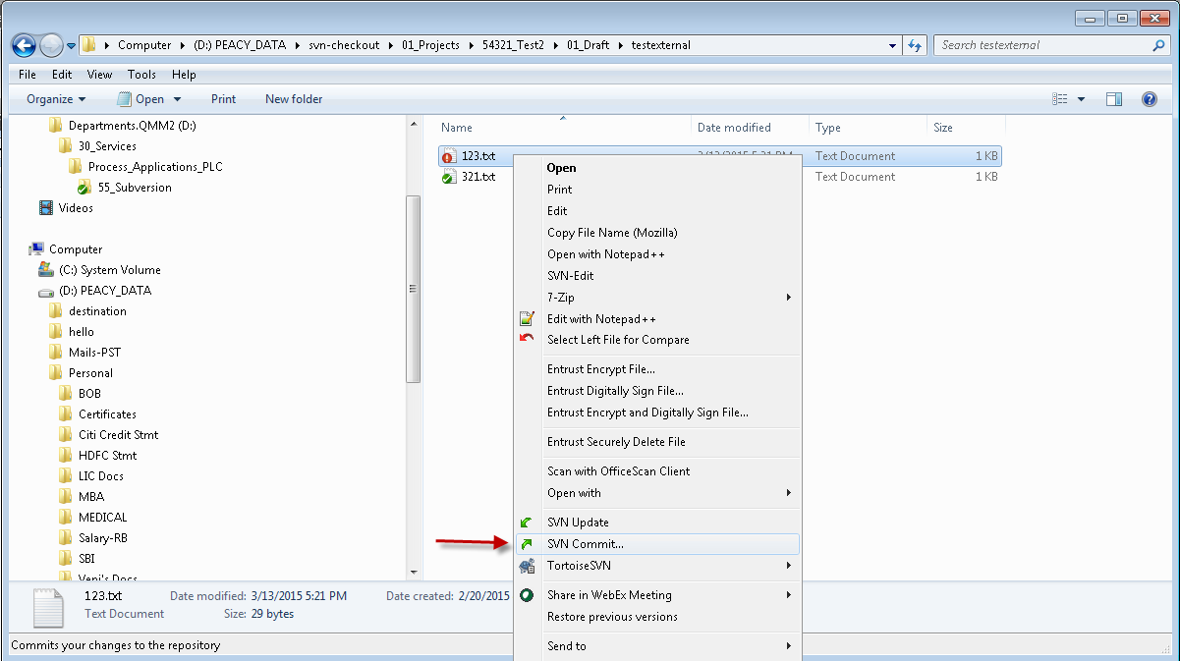

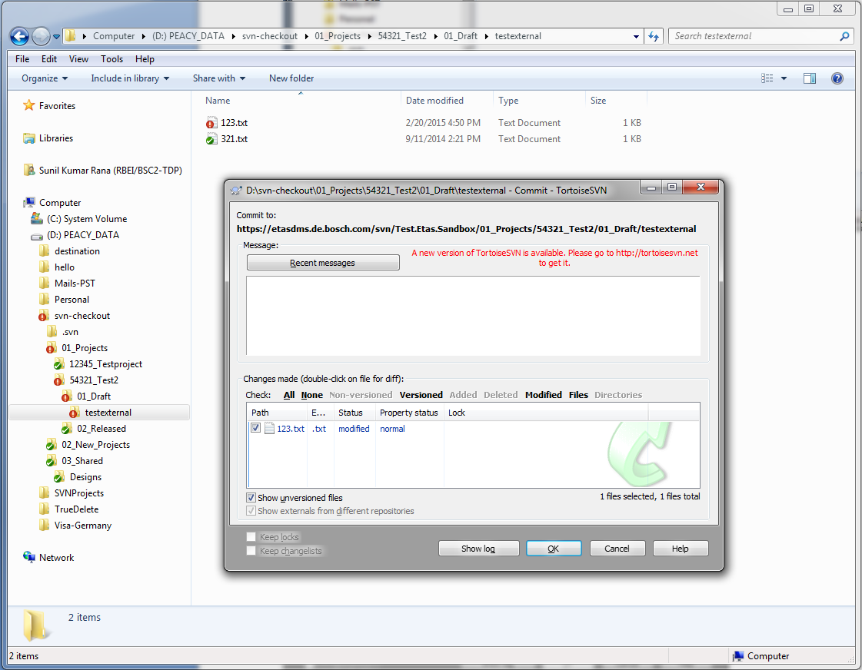

It is highly recommended that you put in a short description of your message you wish to commit into the server. Once you ready, Please click ***OK***.

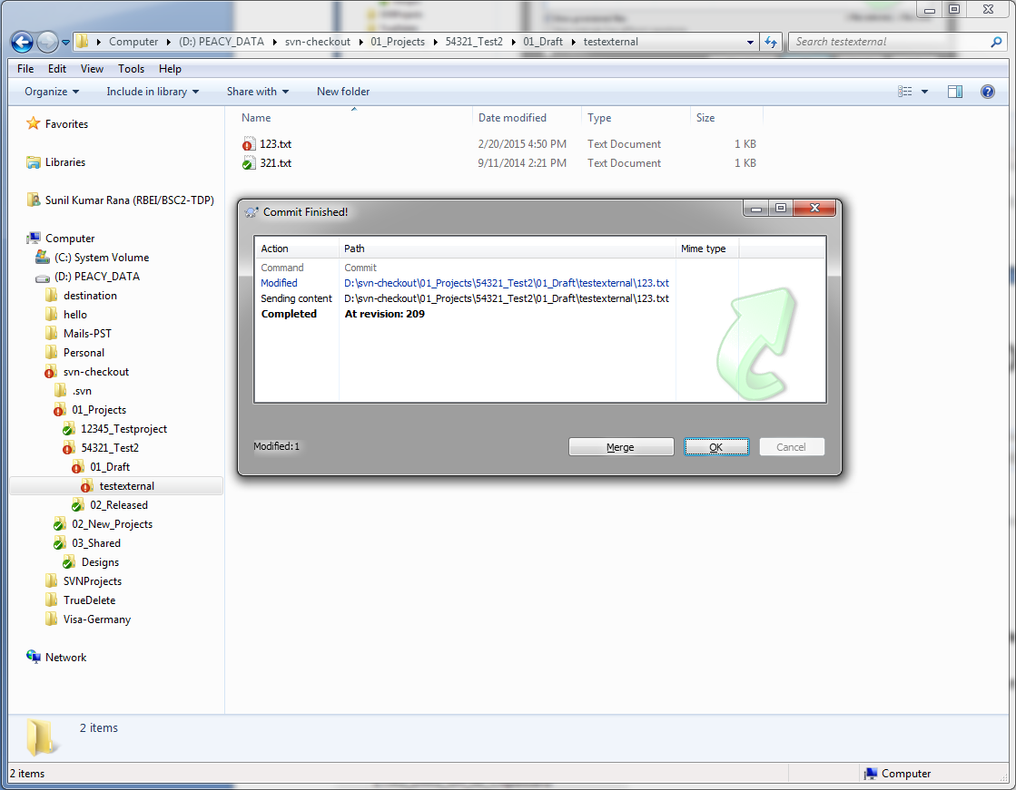

## SVN Add

If you wish to add new files, folders in to your working copy, then simply copy and pasting into working copy won't help. You need to perform SVN Add to add new contents into working copy***.***

Suppose you wish to add the file Test123.txt in to the server through your working copy, then you need to follow the below instructions.

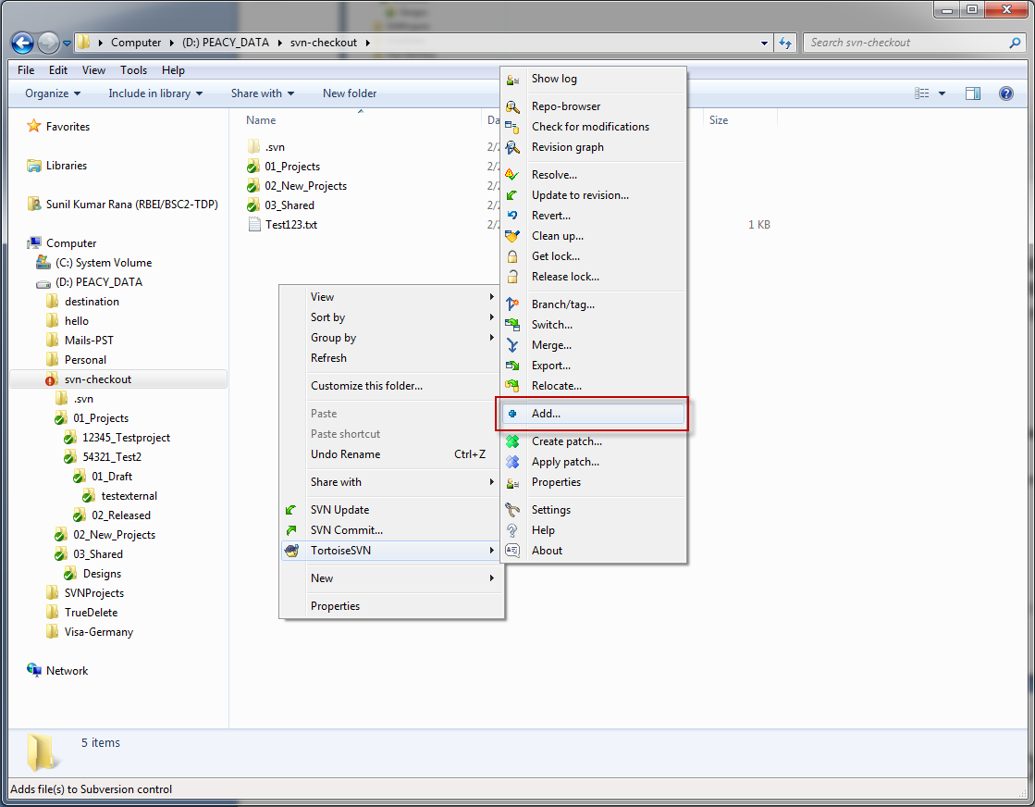

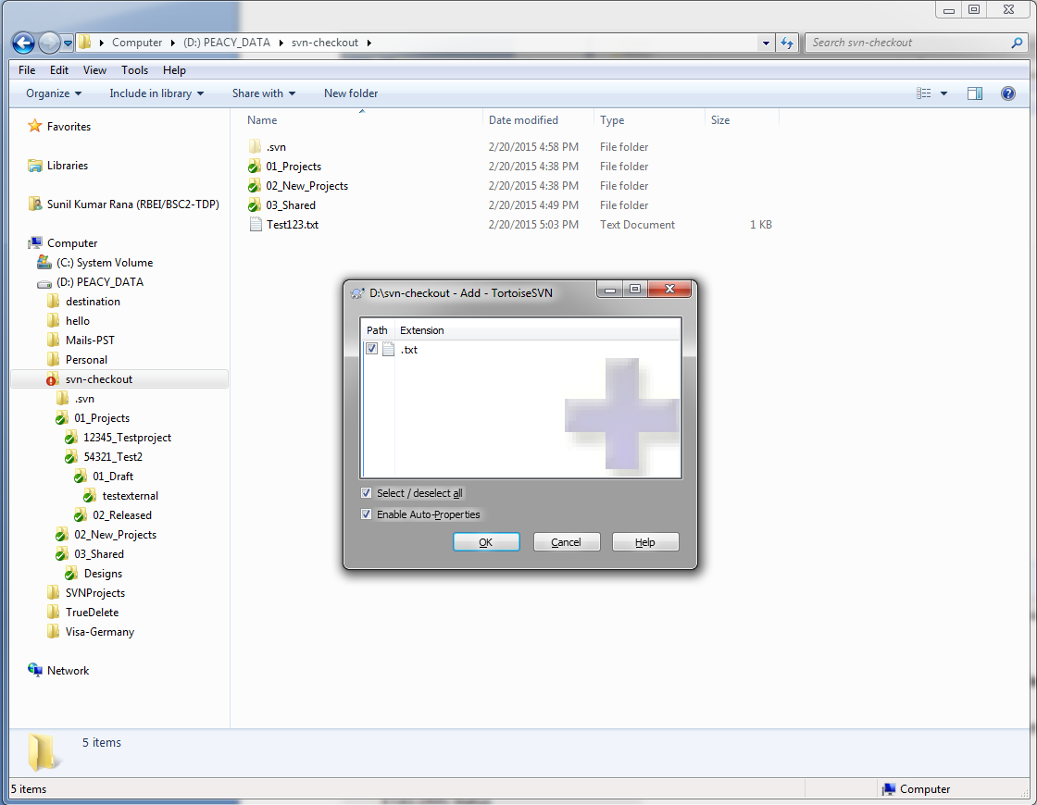

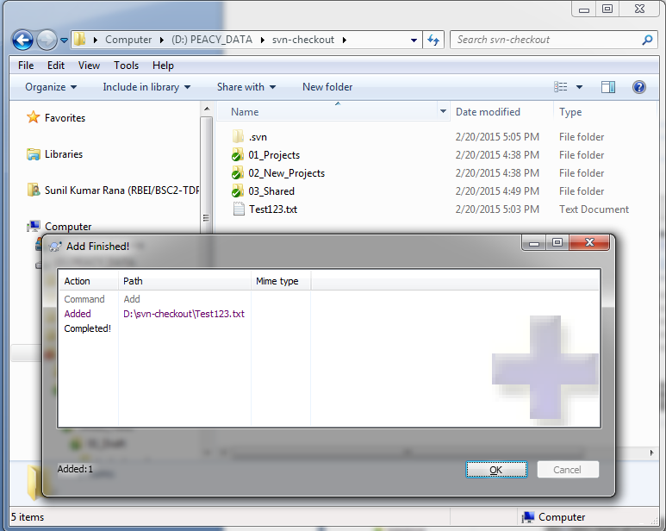

On clicking ok, Add symbol will be visible as shown here

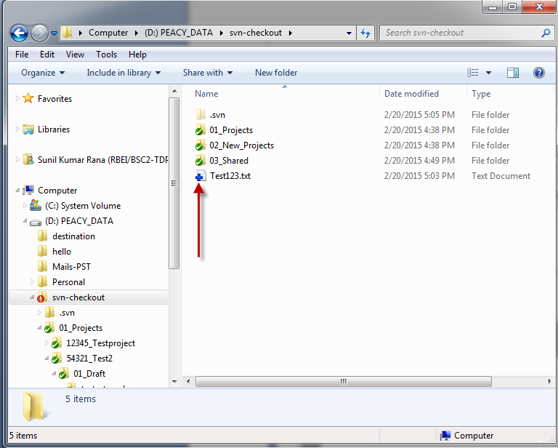

After you see the **plus** mark, you can commit the file by clicking on SVN Commit.

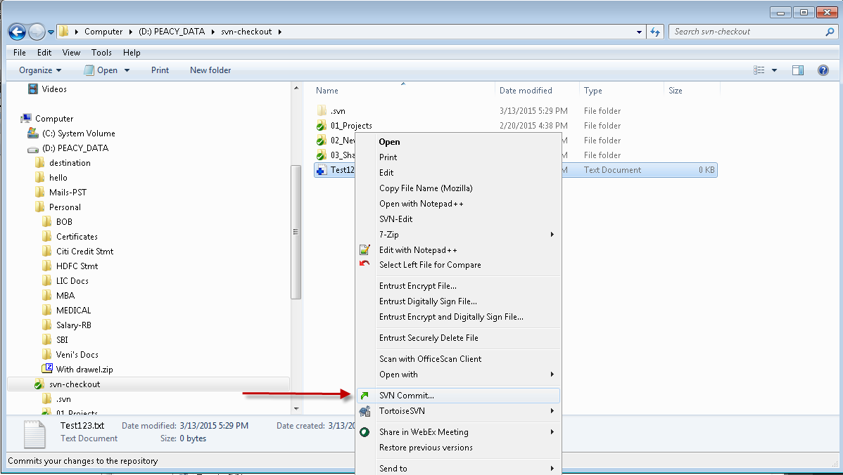

After you click on SVN Commit…, You would see a commit window like below

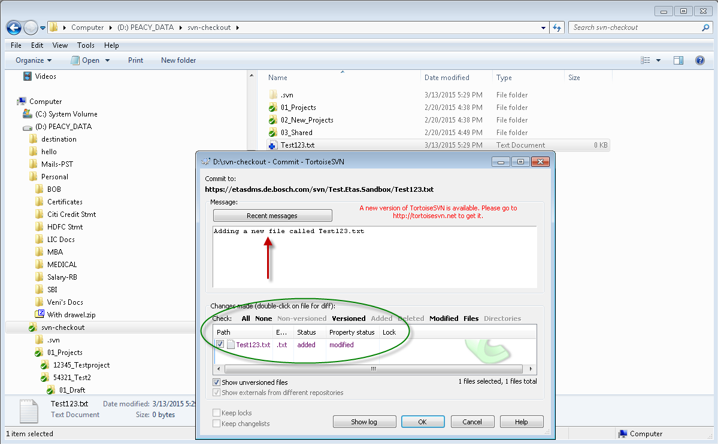

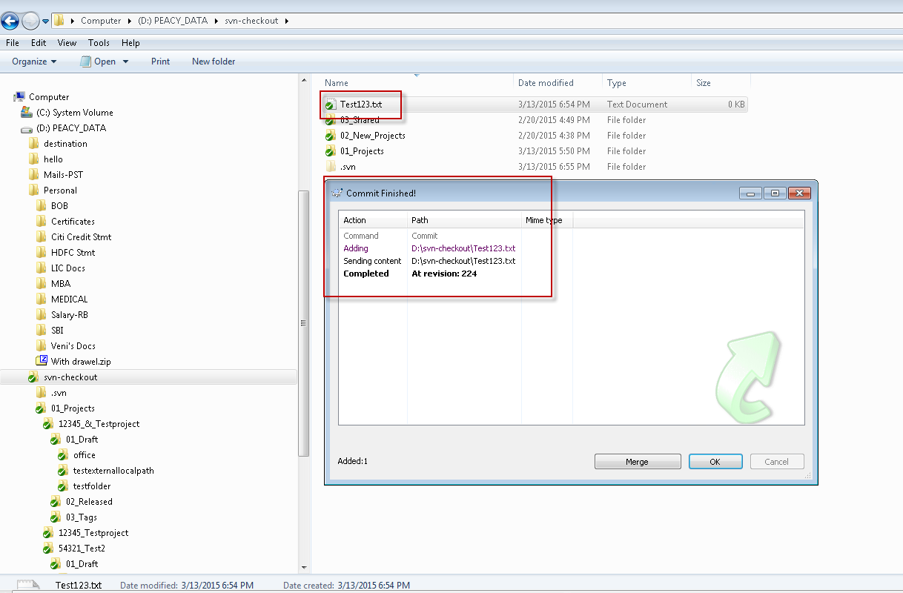

After this, the symbol for newly added files, folders and other contents will change into green symbol meaning that it is checked into the server.

## SVN Repo-browser

SVN Repo-browser would show you all contents of the working copy in browser format. It would help you to freely move inside and outside the folder and perform certain SVN Transactions.

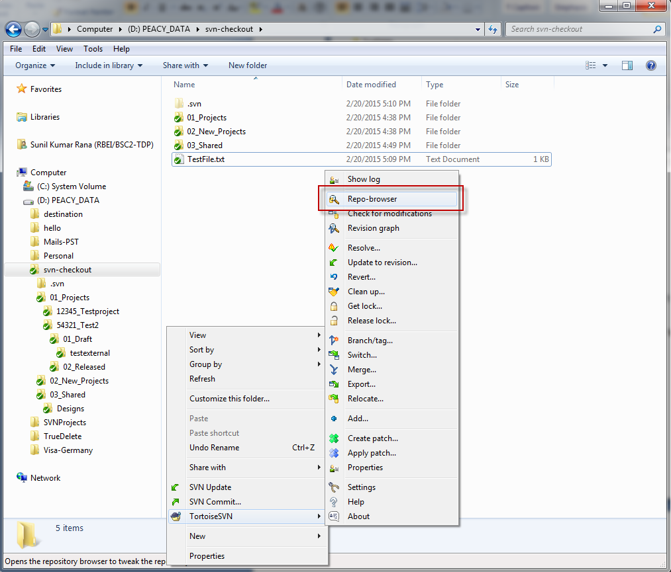

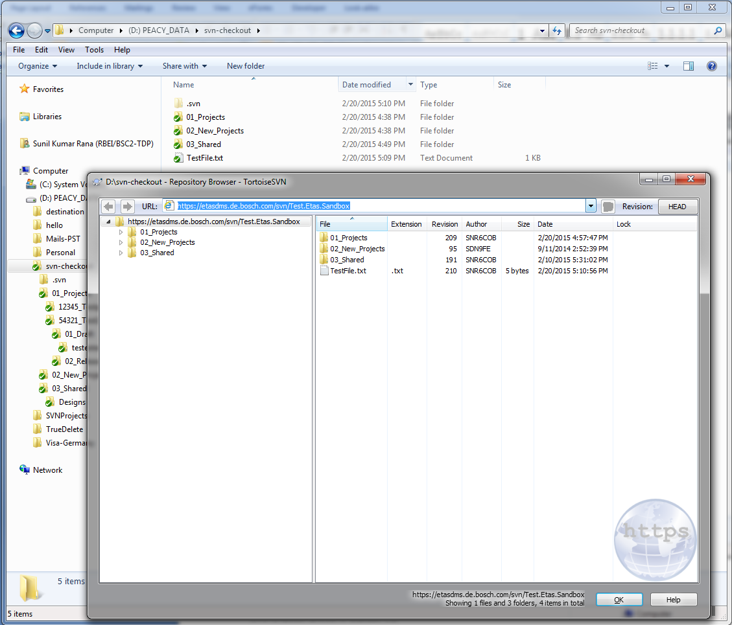

You can perform some SVN actions directly from the Repo-browser like SVN Checkout, SVN Export, SVN Add etc etc.

## Other SVN Features

Other SVN features include SVN Rename, SVN Delete which follows similar instructions like SVN Add.

Also, you check for all the commits and the revisions on your working copy by following the below steps.

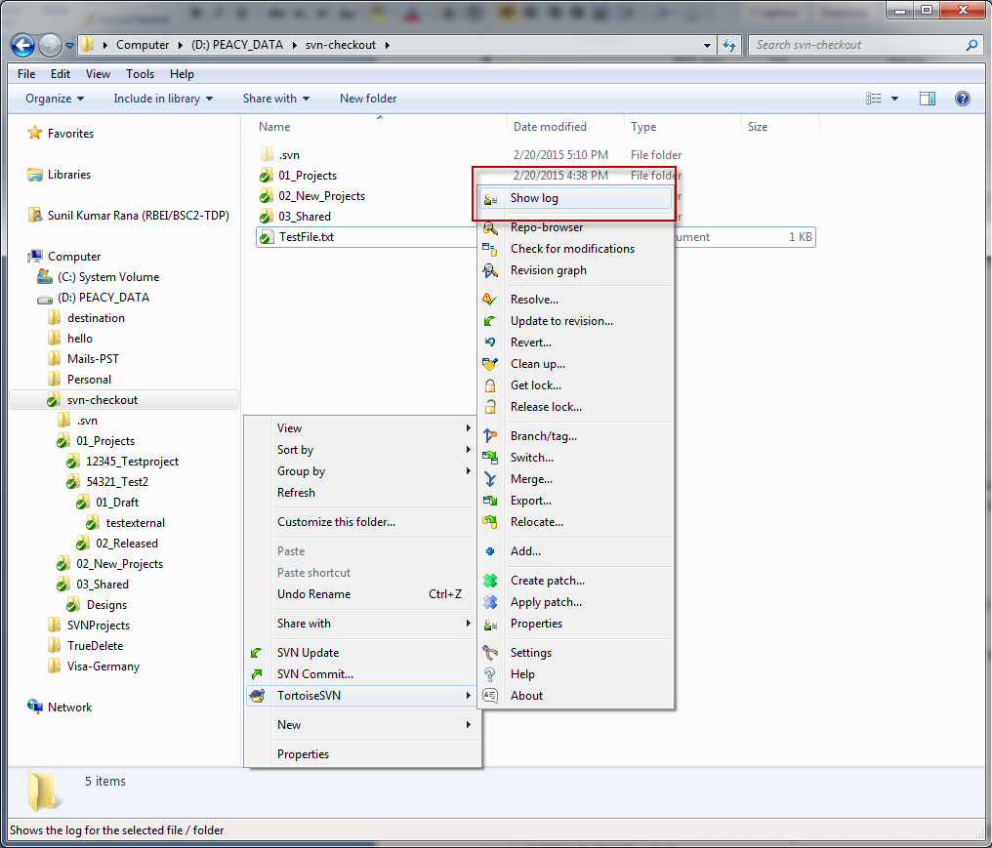

Clicking on ***Show log*** would show you all the logs containing the revisions and other details that have been performed on your subversion working copy.

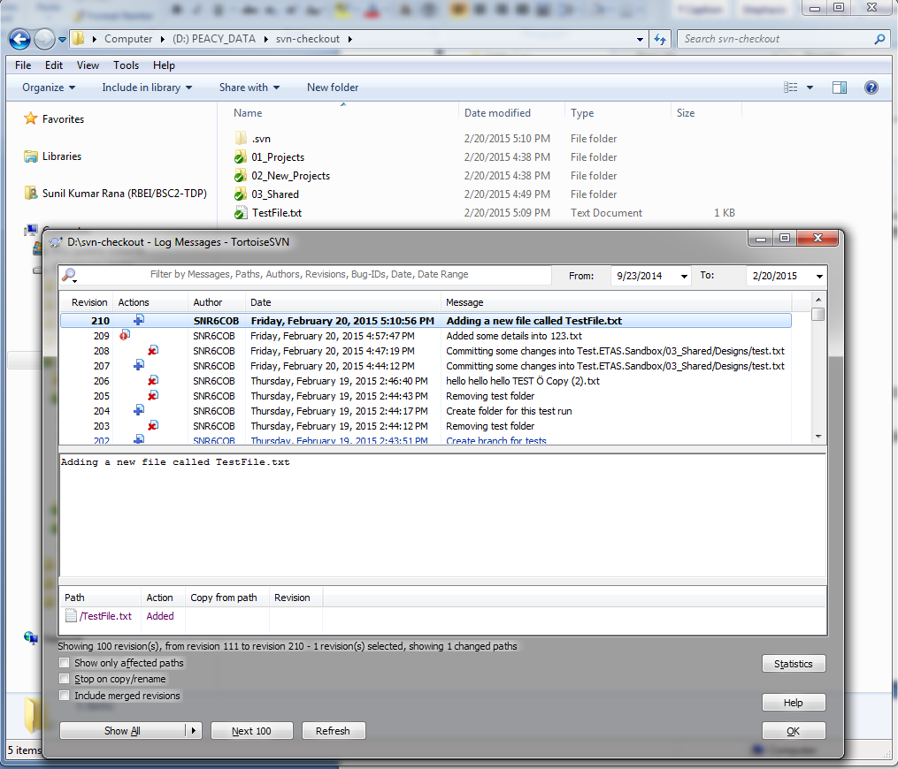

## Features and other uses of ETAS DMS

As described in Installation and Configuration, Several other components are also installed as part of ETAS DMS v3.2.

You can check these options in the context menu by right-clicking on a proper subversion copy.

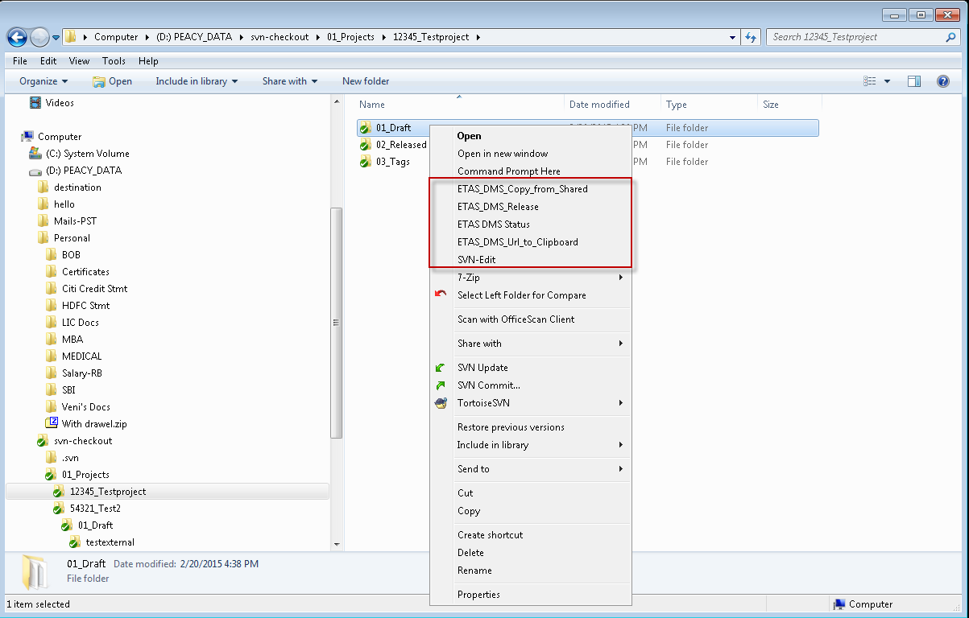

### ETAS DMS Copy from Shared

The Copy from Shared script is used to manually trigger copying selected files from the /03_Shared folder of a repository (or from subfolders) to a project's folder within 01_Draft in the same repository.

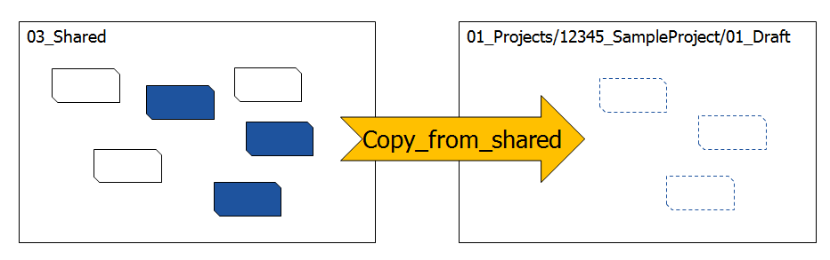

You will be able to initiate the tool only by clicking on 01_Drafts folder where you wish to copy the contents of 03_Shared of that repository in to this folder. Any user can initiate this tool.

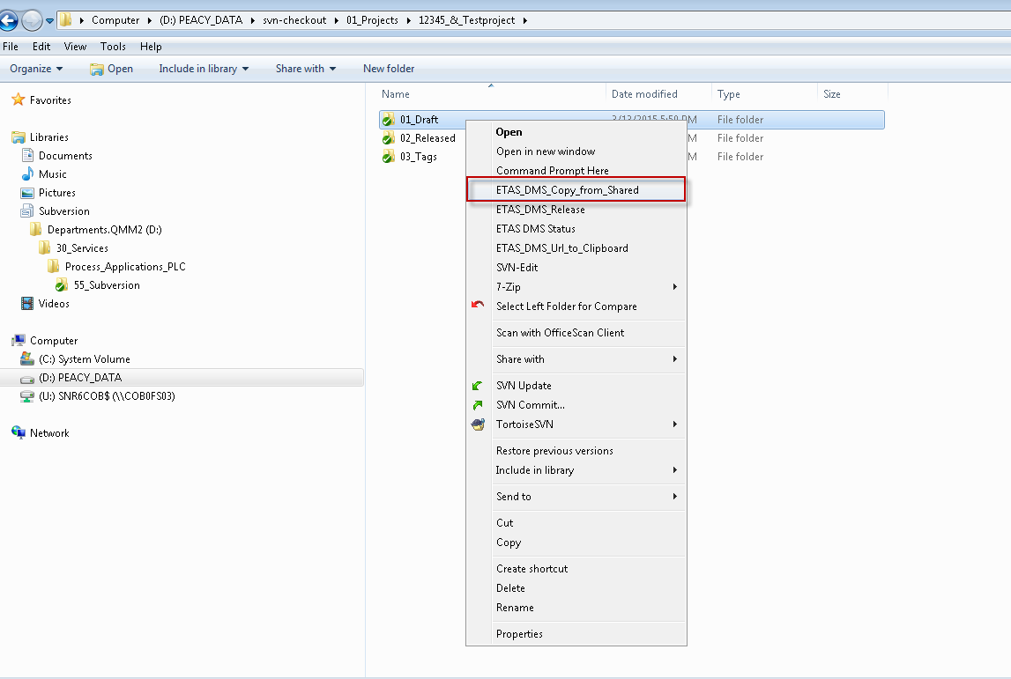

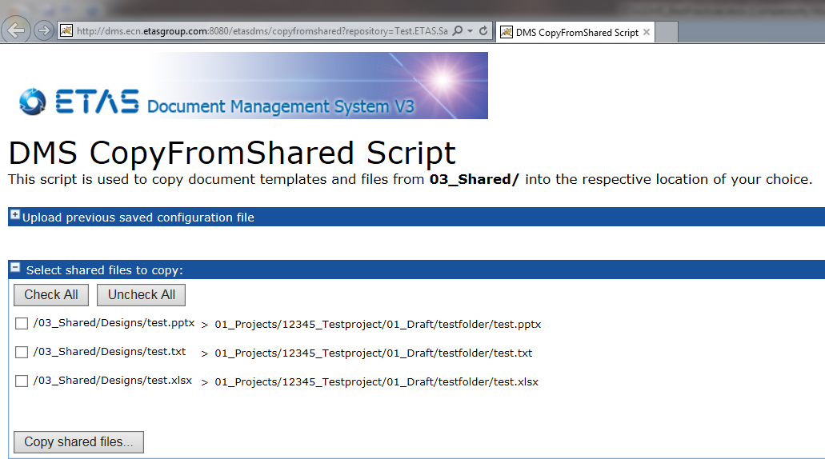

### ETAS DMS Release

ETAS DMS Release tool is only used by Project Manager’s and designed for Project Manager’s to be able to perform baseline of 01_Drafts folder into different releases.

This privilege is available only to Project Manager and not to any other valid user.

Project manager’s having access to perform a release will be able to initiate a release by clicking only on 01_Drafts folder of their repository.

The Release Script is a tool to prepare baselines of the projects documentation. It can be used to copy items from the /01_Draft folder into the /02_Released folder or into a subfolder of /03_Tags of a project

* Features (new):
  + Select Revision which is released
  + Select Target folder for copy operation:
    - Default: 02_Released
    - Others: 03_Tags/<USERDEFINED>
  + Optional clear 02_Released folder before copy
  + save your previously selected files for releasing into a config file which can be imported during the next release

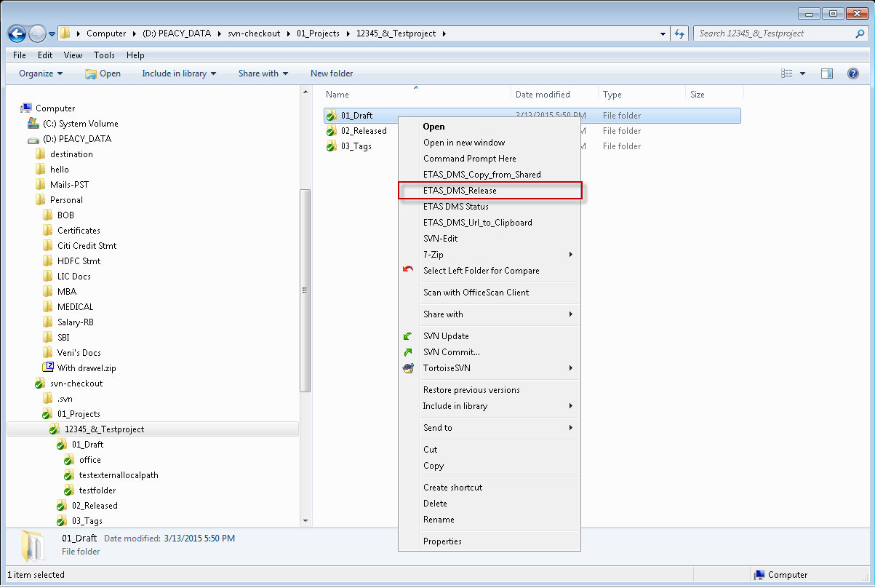

This opens up a web page for the PM/PjM’s to be able to baseline 01_Drafts folder into a release.

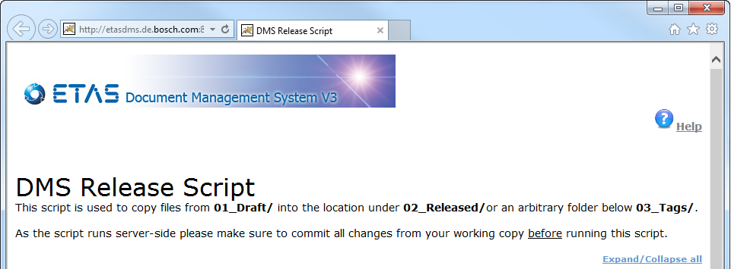

Also, if a file already exists in 02_Released and it is released again, the script first removes the outdated file and replaces it by the new version

### ETAS DMS Status

The DMS Status Tool is used by the Project Managers to set Subversion properties to their project files. The tool provides the following functions:

* Easy multi-change of properties, like "etas:review_state", "etas:project_number", etc.
* Comparison of files in Draft folder with files in Reeased folder
* Integrated into the ETAS tool chain
* Supports Release Script Workflow

Use Case 1: Release Preparation

* + Files which are ready to be released within the next baseline are marked „reviewed“ and are automatically preselected by the Release Script later on
  + Filter and sorting mechanisms of the DMS Status Tool provide a more convenient User Interface than the Release Script
  + Columns indicate, if 01_Draft and 02_Released folder are up to date

Use Case 2: Maintenance of SVN Meta Data (optional)

* + ETAS Specific SVN Meta Data (Project Name, Project Number, Review Status) **may** be maintained using the DMS Status Tool  
    Current regulation (by ETAS/QMM): all documents must contain at least: author, version, status, confidentiality plus: it must be possible to determine the scope of a document (e.g. product, project, etc.)
  + Project Name and Number are derived from the Repository path when using the feature „Set Project“

### ETAS DMS Url to Clipboard

This script is used to copy the URL of a folder into clipboard. It is run by choosing the entry "ETAS DMS URL to Clipboard" in the context menu of folders in the Windows Explorer.

For Example, You want to provide URL of a working copy to your colleague, All you can do is the right-click on the folder inside the working copy and click on ETAS DMS Url to Clipboard.

After this, you paste the URL into an email and can just mail your colleague the URL. So simple it is, right? Makes life easier.

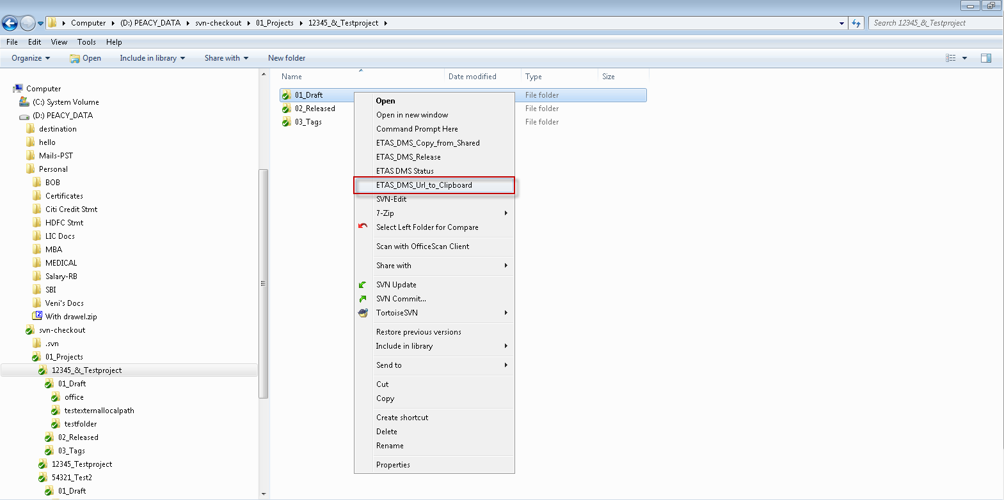

### SVN-Edit

SVN-Edit is a powerful tool that can be used by users to perform updating, locking, committing the changes in the server with only one click. In other words, upon clicking on SVN-Edit, working copy gets updated, then the file is ready for you to modify which gets locked and then all the changes gets checked in to the server at only one click.

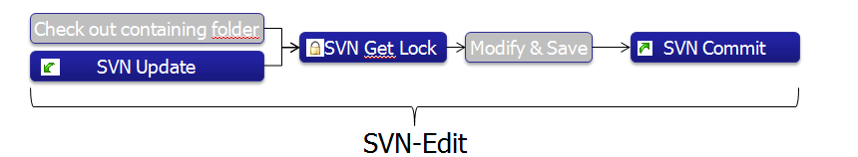

* Purpose: Open file for modifications by one-click
* What it does: SVN Update, SVN Get Lock, open the file,  
  open SVN Commit Dialog in Background
* The tool does only work on single files! Neither on a set of files nor on folders.

For example, I wish to edit a file 123.txt and directly commit into the server, then I need to click on SVN-Edit available on the context menu.

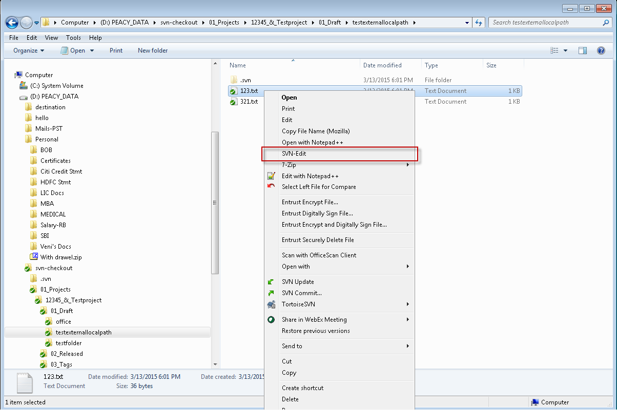

Upon Clicking SVN-Edit, it perform series of instructions one after another i.e.

* SVN Update – Updates the local working copy.
* SVN Get Lock by current user- Lock is attained by the current user.
* Opens the file for the user to edit, and then after modifying the file, user can close the file.
* Following which SVN Commit dialog box would appear asking the user to put commit message.
* Once clicked on OK, Changes are now committed into the server by a single click.